**Atliq Mart Promotional Campaign Analysis-Codebasics Resume Challenge 9**

# ****INTRODUCTION:****

Atliq Mart is a retail giant with over 50 supermarkets in the southern region of India. All their 50 stores ran a massive promotion during Diwali 2023 and Sankranti 2024 (festive time in India) on their Atliq branded products.

**DOMAIN: FMCG**

# ****PROBLEM STATEMENT:****

Analyse promotions and provide tangible insights to the sales director to make more informed decisions over the next promotional period.

# ****TOOLS USED:****

**MySQL Workbench:**Creating SQL queries for ad-hoc business requests.

**PowerBI:**For Data cleaning, modeling, creating metrics using DAX, and data visualization.

# ****SOURCE DATA & RELATIONSHIP ENTITY DIAGRAM:****

* The 4 datasets provided are in the CSV file format.
* There are **3 dimension** tables namely, **dim_campaigns, dim_products and dim_stores and 1 fact_table which is fact_events.**
* The **dim_campaigns** table contains information regarding the two festive periods, i.e., **Diwali 2023 and Sankranti 2024** with the starting and ending date of the festive offers, where campaign_id is the table's primary key.
* The **dim_products** table contains information regarding product_code, product_name, and the category to which the product belongs, where product_code serves as the primary key for the table.
* The **dim_stores** table contains information regarding the store_id and the city where the store is present, where store_id serves as the primary key for the table.
* The **fact_events** tables consist of all the quantitative data which contains information about campaign_id, product_code, store_id, promo_type, base price of the product, quantity sold before the offer, and quantity sold after the offer.

**ADHOC BUSINESS REQUESTS**

There are 5 adhoc business requests and the subsequent information is extracted using MySQL.

**PROBLEM 1:**Provide a list of products with a base price greater than 500 and that are featured in the promo type of ‘BOGOF’ (Buy One Get One Free). This information will help us identify high-value products that are currently being heavily discounted, which can be useful for evaluating our pricing and promotion strategies.

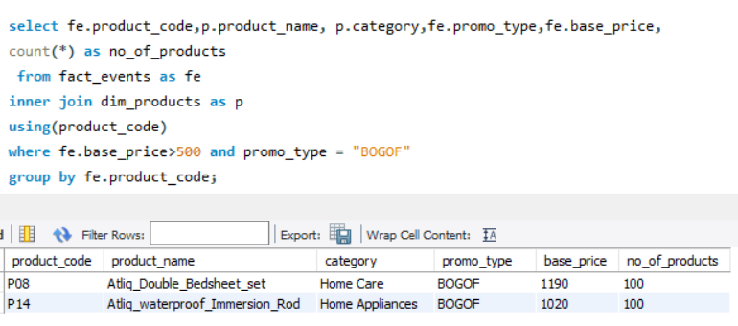

**RESULT: Atliq_Double_Bedsheet_set** and **Atliq_Waterproof_Immersion_rod** are the two products whose base price is greater than Rs. 500 and that is featured in the ‘BOGOF’ promo type.

**PROBLEM 2:**Generate a report that provides an overview of the number of stores in each city. The results will be sorted in descending order of store counts, allowing us to identify the cities with the highest store presence. The report includes two essential fields: city and store count, which will assist in optimizing our retail operations.

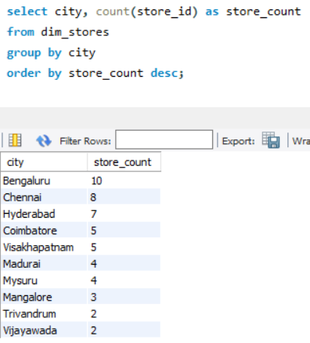

**RESULT: Bengaluru**has the highest number of stores with a store count of 10 while **Trivandrum**and **Vijayawada**have the lowest number of stores with a store count of 2 each.

**PROBLEM 3:**Generate a report that displays each campaign along with the total revenue generated before and after the campaign. The report includes three key fields: campaign_name, totaI_revenue(before_promotion), and totaI_revenue(after_promotion). This report should help in evaluating the financial impact of our promotional campaigns. (Display the values in millions).

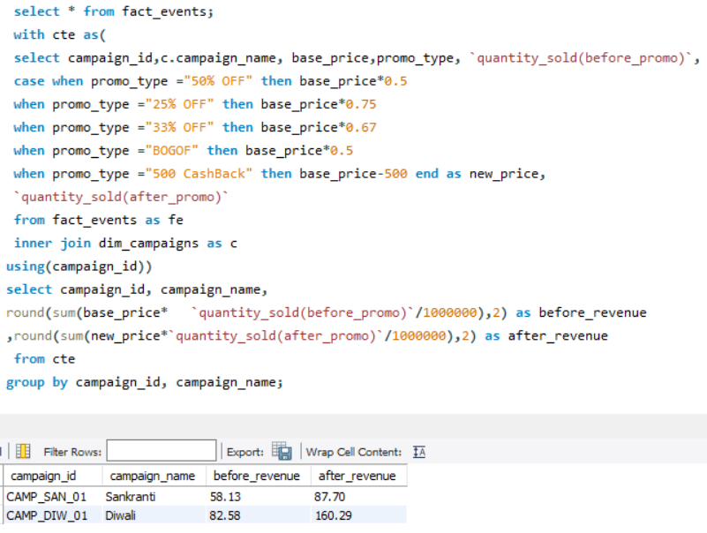

**RESULT:**For **Diwali**, the revenue before the offer was**Rs. 82.57 million**; after the offer was applied, it was **Rs. 160.29 million (an increase of 94% in revenue)**. For **Sankranti**, the revenue before the offer was Rs**. 58.13 million** and after the offer was applied, the revenue turned out to be **Rs. 87.70 million (an increase of 50.86% in revenue)**.

**PROBLEM 4:**Produce a report that calculates the Incremental Sold Quantity (ISU%) for each category during the Diwali campaign. Additionally, provide rankings for the categories based on their ISU%. The report will include three key fields: category, isu%, and rank order. This information will assist in assessing the category-wise success and impact of the Diwali campaign on incremental sales.

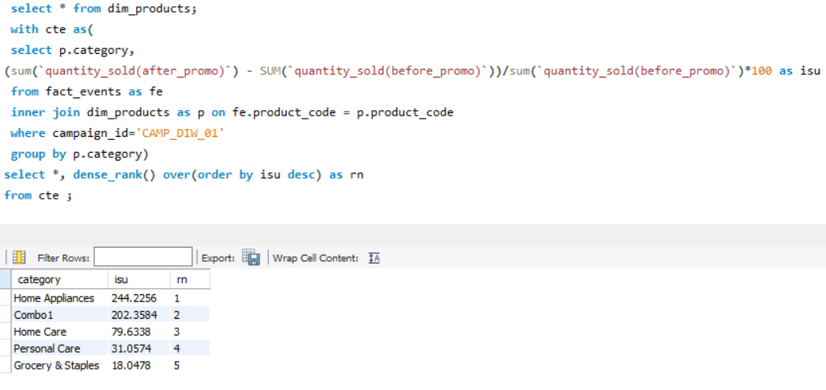

**RESULT:**The **home appliance** category has the **highest ISU (244.23)** while **grocery and staples** have the **lowest ISU (18.05).**

**PROBLEM 5:**Create a report featuring the Top 5 products, ranked by Incremental Revenue Percentage (IR%), across all campaigns. The report will provide essential information including product name, category, and ir%. This analysis helps identify the most successful products in terms of incremental revenue across our campaigns, assisting in product optimization.

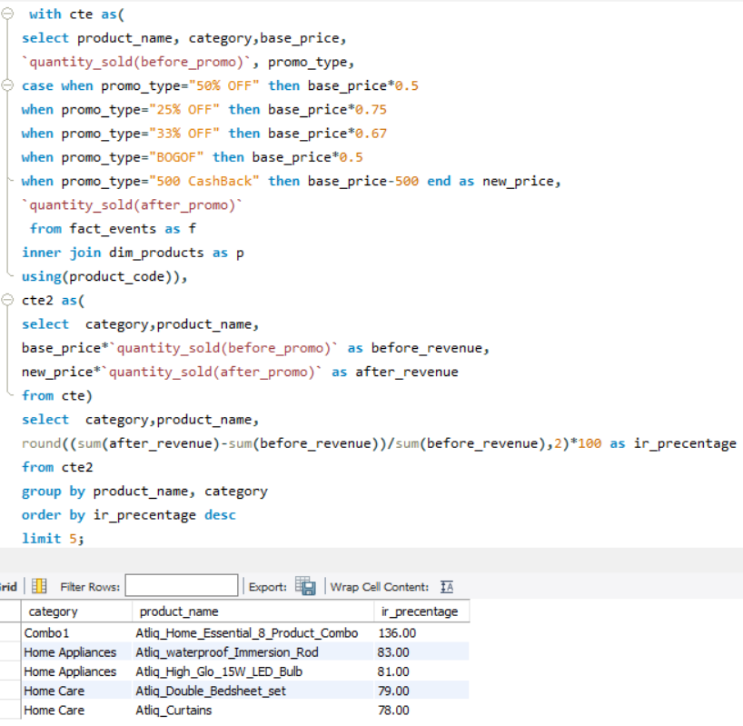

**RESULT: Atliq_Home_Essential_&_Product_Combo**has the highest incremental revenue(IR) of **136%. Atliq_Waterproof_Immersion_rod, Atliq_High_Glow_15W_LED_Bulb, Atliq_Bedsheet_set and Atliq_Curtains** have the IR of **83%, 81%, 79%**and**78%** respectively.

# ****RECOMMENDED INSIGHTS:****

Now, the insights gathered from the analysis of the records of the Atliq Mart is provided below:

**Store Performance Analysis:**

**1.** Which are the top 10 stores in terms of Incremental Revenue (IR) generated from the promotions?

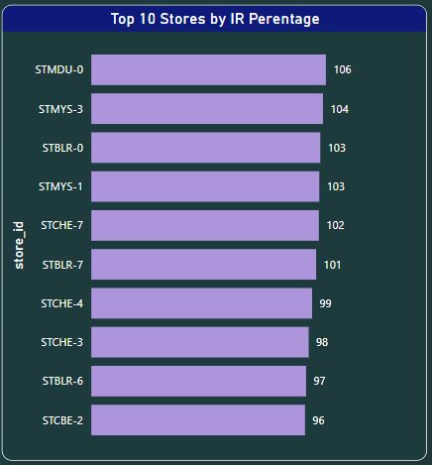

**STMDU-0, STMYS-3, STBLR-0, STMYS-1, STCHE-7, STBLR-7, STCHE-4, STCHE-3, STBLR-6, and STCBE-2**are the top 10 stores with highest incremental revenue.

2. What are the bottom 10 stores' Incremental Sold Units (ISU) during the promotional period?

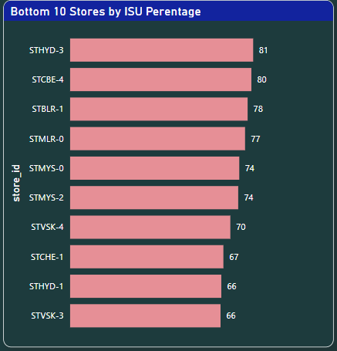

**STVSK-3, STHYD-1, STCHE-1, STVSK-4, STMYS-2, STMYS-0, STMLR-0, STBLR-1, STCBE-4, and STHYD-3**are the bottom 10 stores concerning incremental sold units.

3. How does the performance of stores vary by city? Are there any common characteristics among the top-performing stores that could be leveraged across other stores?

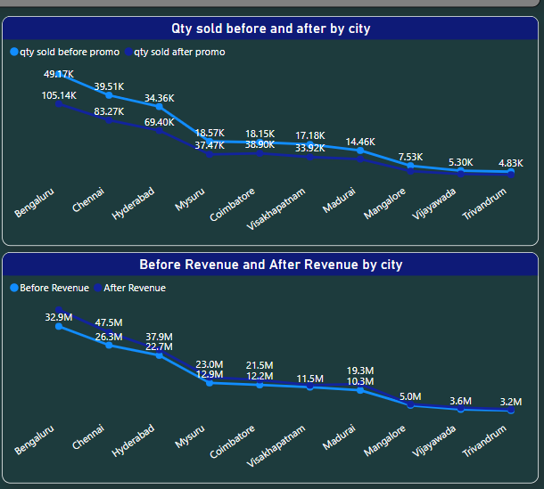 **Bengaluru, Hyderabad, and Chennai**are the top cities generating the highest revenue, while, **Trivandrum**and **Vijayawada** are the lowest revenue-generating cities.

The common characteristic among the top revenue-generating cities is the number of store counts which are more in these as compared to the rest of the cities.

## **Promotion Type Analysis:**

1. What are the top 2 promotion types that resulted in the highest Incremental Revenue?

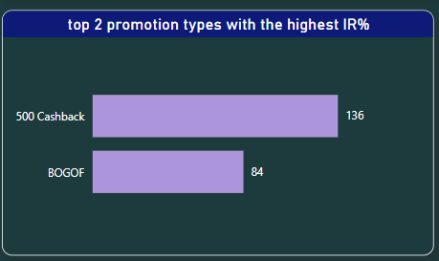

**500 Cashback and BOGOF**are the top 2 promotional offer with the IR percentage of 136 and 84 respectively.

2. Which are the bottom 2 promotion types in terms of their impact on Incremental Sold Units?

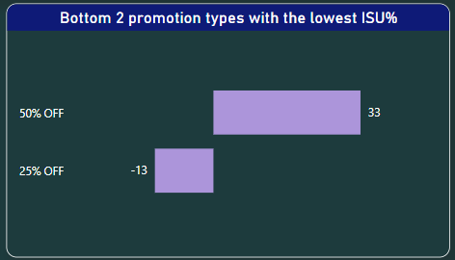

**50% OFF and 25% OFF**are the least availed promo type by the customers.

3. Is there a significant difference in the performance of discount-based promotions versus BOGOF (Buy One Get One Free) or cashback promotions?

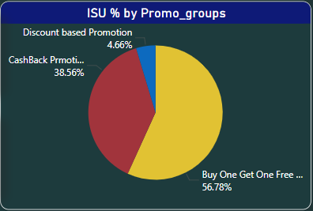

The effect of **ISU**due to the promotional offers is as follows:

**56.78% of ISU** is increased due to the **Buy One Get One Free**offer, with a **38.56%** increase in ISU due to the **Cashback**promotions and **Discount-based**promotions affecting the least with 4.66%.

4. Which promotions strike the best balance between Incremental Sold Units and maintaining healthy margins?

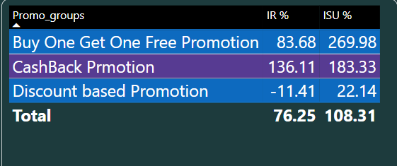

**Cashback promotions** strike the best between incremental sold units and maintain healthy margins.

## **Product and Category Analysis:**

1. Which product categories saw the most significant lift in sales from the promotions?

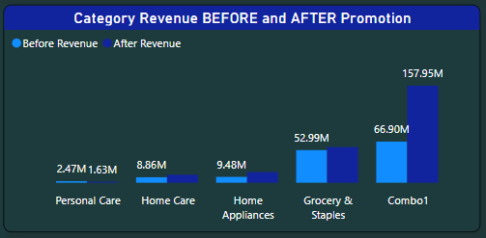

**Combo 1 and Grocery and Staples** stand out as the top revenue-generating categories post-offer, underscoring the significant impact of the promotional offer on these two categories. However, the **Home Appliance category** possesses the **highest ISU**, indicating that its products sold more than the other categories.

2. Are there specific products that respond exceptionally well or poorly to promotions?

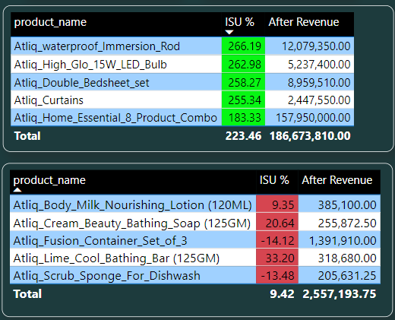

**Atliq_home_essential_&_product_combo**is the product which experienced a major positive impact by the promotion, where its revenue increased from 67 million to 158 million and quantity sold from around 22k to 63k after the promotional period, while the products which had almost minimal impact on the sales were **Atliq_Scrub_Sponge_for_Dishwash, Atliq_cream_beauty_bathing_soap(125 gm), Atliq_lime_cool_bathing_bar(125 gm), Atliq_body_milk_nourishing_lotion(120 ml), Atliq_doodh_kesar_body_lotion(200ml).**

3. What is the correlation between product category and promotion type effectiveness?

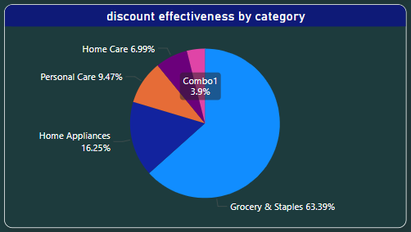

**Grocery and staples**benefited the maximum with the promotional offers while **Combo1** experienced the least impact.

**SUMMARY**

1. **Diwali vs. Sankranti Campaigns:** Diwali was the most successful, with revenue increasing by 94% (Rs. 82.57M to Rs. 160.29M), compared to a 50.86% increase during Sankranti (Rs. 58.13M to Rs. 87.70M).
2. **Category Performance:** Home appliances had the highest ISU, but Combo 1 and Grocery & Staples generated the most revenue post-offer, showing a strong promotional impact.
3. **City Performance:** Bengaluru, Chennai, Hyderabad, Mysuru, and Coimbatore contributed 70–75% of total revenue. Vijayawada and Trivandrum, with only 2 stores each, saw revenue increase by 1.5x and 2x, suggesting potential for expansion.
4. **Promotion Effectiveness:** BOGOF and Cashback offers were more popular than discounts, with Cashback being the best for balancing sales growth and healthy margins.

PROJECT LINK: <https://github.com/bhargavi-mar/Atliq_Mart_Promotional_Campaign_Analysis/tree/main>